THE MAGICAL KERALA TOUR
Destinations Covered: COCHIN - MUNNAR - PERIYAR - KUMARAKOM - ALLEPEY - COCHIN
Duration: 09 Nights / 10 Days
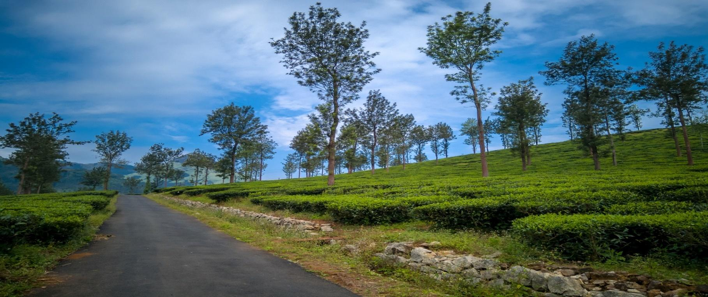

DAY 01: ARRIVAL AT KOCHI
Upon arrival at Kochi Airport, you will be greeted by our representative who will assist with your transfer to the hotel. Kochi, also known as Cochin, is a fascinating blend of history, culture, and modernity. Over the centuries, it has been shaped by the influence of the British, Arabs, Chinese, Dutch, and Portuguese, making it one of India’s most cosmopolitan cities. With its charming colonial architecture, bustling spice markets, and serene waterfront, Kochi is the perfect starting point to explore the beauty of Kerala, fondly called “God’s Own Country.” After check-in, spend the rest of the day relaxing at the hotel or taking a leisurely evening stroll. Overnight stay in Kochi.
DAY 02: KOCHI SIGHTSEEING
After breakfast, embark on a guided sightseeing tour of Kochi. Begin with Fort Kochi, a historic coastal area that showcases the city’s colonial past through its architecture and quaint streets. Within the fort complex, visit the St. Francis Church, the oldest European-built church in India, dating back to 1503. Its simple yet majestic structure reflects the charm of a bygone era. Continue to the Jewish Synagogue in Mattancherry, built in 1568, where you can admire hand-painted Chinese tiles, Belgian glass chandeliers, rare antiques, and an impressive gallery. The day’s highlights also include the famous Chinese Fishing Nets, an iconic symbol of Kochi, believed to have been introduced by Chinese explorer Zheng He. Watching fishermen operate these massive bamboo and teakwood contraptions, especially during sunset, offers a perfect photo opportunity. In the evening, immerse yourself in Kerala’s cultural heritage by attending a Kathakali dance performance, where elaborate costumes, expressive gestures, and vibrant makeup bring ancient stories to life. Overnight stay in Kochi.

DAY 03: KOCHI TO MUNNAR (165 km / ~5 hrs)
After breakfast, begin a scenic drive to Munnar, a hill station renowned for its lush tea plantations, mist-covered mountains, and cool climate. Situated at the confluence of three rivers—Madhurapuzha, Nallathanni, and Kundaly—Munnar is a haven for nature lovers and honeymooners alike. It is home to Anamudi, the highest peak in South India, and is surrounded by wildlife sanctuaries that protect species such as the Nilgiri Tahr, grizzled giant squirrel, and sambar deer. Every twelve years, the slopes of Munnar are blanketed in blue by the rare Neelakurinji flower, making it a truly magical sight. Upon arrival, check into your hotel and enjoy the rest of the day at leisure, taking in the fresh mountain air. Overnight stay in Munnar.

DAY 04: MUNNAR SIGHTSEEING
Start your day with a visit to Munnar’s sprawling tea estates, where emerald-green plantations stretch as far as the eye can see. Enjoy a guided walk through the tea gardens, learning about the intricate process of cultivation and plucking, followed by a visit to the Tea Museum. Here, you can explore exhibits that include vintage photographs and historic machinery used in tea production. Continue to Eravikulam National Park, Kerala’s first national park and a sanctuary for the endangered Nilgiri Tahr. The park’s rolling hills offer spectacular views and, during blooming years, are carpeted with Neelakurinji flowers. Conclude the day with a stop at Mattupetty Dam, a serene spot where the still waters mirror the surrounding tea gardens, creating a postcard-perfect scene. Return to the hotel for an overnight stay in Munnar.

DAY 05: MUNNAR TO THEKKADY (110 km / ~3.5 hrs)
After breakfast, depart for Thekkady, a captivating destination nestled in the Western Ghats. Known as the gateway to Periyar Wildlife Sanctuary, Thekkady’s landscapes are dotted with spice plantations, dense forests, and rolling hills. Upon arrival, check into your hotel and take the rest of the day to unwind, enjoying the peaceful atmosphere of this nature-rich region. Overnight stay in Thekkady.

DAY 06: THEKKADY SIGHTSEEING
After breakfast, set out to explore the Periyar Wildlife Sanctuary, one of India’s most celebrated tiger reserves. A highlight here is the boat cruise on Periyar Lake, offering the chance to spot elephants bathing, deer grazing, and a variety of bird species along the shoreline. Continue with a spice plantation tour, where the fragrant aroma of cardamom, pepper, cinnamon, and cloves fills the air. Learn about traditional cultivation and harvesting methods that have made Kerala a spice capital for centuries. Return to your hotel and enjoy an overnight stay in Thekkady.

DAY 07: THEKKADY TO KUMARAKOM (145 km / ~4 hrs)
After breakfast, drive to Kumarakom, a tranquil backwater village set on the banks of Vembanad Lake. Upon arrival, visit the Kumarakom Bird Sanctuary, a paradise for birdwatchers where you can spot migratory species such as Siberian cranes alongside local waterfowl. Later, check into your hotel and enjoy a relaxing evening. If you wish, you can opt for a sunset cruise on the Vembanad Lake, watching the sky turn shades of orange and pink over the still waters. Overnight stay in Kumarakom.

DAY 08: KUMARAKOM TO ALLEPPEY (40 km / ~1 hr)
After breakfast, travel to Alleppey, famously called the “Venice of India” for its intricate network of canals, lagoons, and backwaters. Upon arrival, board a traditional houseboat, known locally as a kettuvallam. As you cruise along the serene waterways, observe daily life in the backwater villages, see paddy fields shimmering in the sun, and pass coconut palms swaying gently in the breeze. Enjoy freshly prepared Kerala meals on board, accompanied by the soothing sounds of nature. Overnight stay on the houseboat in Alleppey.

DAY 09: ALLEPPEY TO KOCHI (54 km / ~1.5 hrs)
After breakfast on the houseboat, disembark at the Alleppey jetty and drive back to Kochi. Check into your hotel and enjoy the remainder of the day at leisure, perhaps indulging in some last-minute shopping or revisiting your favourite spots in the city. Overnight stay in Kochi.

DAY 10: DEPART KOCHI
After breakfast, you will be transferred to Kochi Airport to board your flight home, carrying with you cherished memories of Kerala’s scenic landscapes, vibrant culture, and warm hospitality.

“END OF THE TOUR”

HOTELS ENVISAGED
CITY | 3 STAR HOTELS | NIGHTS
COCHIN | GINGER | 2
MUNNAR | MISTY MOUTAIN RESORT | 1
PERIYAR | PEPPERVINE | 2
KUMARAKOM | LAKESONG | 1
ALLEPEY | KERALA CRUISE HOUSEBOAT | 1

PRICING (VALID FROM 1ST APRIL TO 30TH SEPTEMBER 2024) – 2 TO 6 PAX TRAVELLING

PARTICULARS | 3 STAR
2 PAX – 1 DOUBLE ROOM | USD 730 PER PERSON

YOUR TOUR PACKAGE INCLUDES:

- 9 Nights’ Accommodation as per the mentioned or similar hotels.
- Daily buffet breakfast at the hotels.
- All transfers from Airports with assistance.
- Transportation in Air-conditioned Vehicle for all transfers and sightseeing.
- Professional & well-dressed driver, with excellent driving skills and good knowledge of the routes.
- Experienced English-speaking guide during the sightseeing in Cochin Only.
- Spice Plantation Tour in Thekkady.
- Katthakali Dance Show in Cochin.
- Boat Ride at Periyar Lake.
- 1 Mineral Water Bottle every day. (Per person)
- All toll, parking, fuel charges and interstate taxes.
- All applicable taxes and service charges.

YOUR TOUR COST DOES NOT INCLUDE:

- Medical and insurance of any kind.
- Any lunch or dinner.
- Any air fare (Domestic & International).
- Indian Visa.
- Monuments Entrance Fees.
- Camera Fee at Monuments.
- Any expenses arising out of unforeseen circumstances like flight delay/cancellation/hike in fare, strike or any other natural calamities.
- Personal nature Expenses I.e. Telephone Calls, Laundry, Soft / Hard Drinks, Meals, Tipping etc.

Important Information:

24-Hour Assistance: Your dedicated Travel Expert can be reached at any time in case of emergency in order to assist you or answer your questions. GeTS Holidays has offices all over India and our local team will be able to assist you if needed.

Hotel: Standard Check-in time is at 14:00, check-out is at 12:00. (early check-in and late check-out is subject to availability)

Internet: Depending on the areas in which you travel, you may have limited access to the Internet. Hoteliers often charge for the connection (hourly or daily).

Tipping: Tipping is completely a personal gesture and depends on the service and assistance you get.
The usual norm per day is USD 10 for the driver, USD 15 for the guide and USD 2-4 to a bellboy and 5-10% of the bill (to a waiter) serving you in a restaurant.

Luggage: For domestic flights, you are entitled to 15 kg luggage and 7 kg hand baggage. The supplement is approx. 600 INR (about 7-8 USD) per additional kilo. However, this may vary as per each airline policy.

Passports and Visas: All travelers must be in possession of a valid passport and all relevant visas. It is your responsibility to ensure that you have valid travel documentation, including but not limited to passports and visas, which meet the requirements of immigration and other government authorities at every destination. If your itinerary includes travel to any other country besides India, please check on visa requirements for each country that you will visit. Any fines, penalties, payments or expenditures incurred as a result of such documents not meeting the requirements of those authorities will be your sole responsibility.

Visas for India:
- Valid visas are required for everyone coming from overseas.
- The visas are issued electronically (e-Visa) or can be obtained from the Indian missions abroad through application. E-Visa is available in many countries of Europe, and US and Australia etc.
- Guests’ passport should have at least 02 blank pages and the passport should have minimum 6 months’ validity.
- You can apply for an e-Visa on Indian government website; the visa application should be made at least 7 to 30 days prior to the arrival date in India.
- An approval normally takes in advance of the travel date and an approval normally takes 72 hours after application.
- Details can be found at https://indianvisaonline.gov.in/evisa/tvoa.html

Multiple Entry Visa: If your travel itinerary includes travel to India and any other country (Nepal, Bhutan, Tibet, Sri Lanka etc.), you may require a multiple entry Indian Tourist visa. You will be required to present your travel itinerary and documentation at the time of application for the visa.

Other Important Information:
- Vaccinations: Ensure you are up to date on routine vaccinations and consider additional vaccines recommended for travel to India. (Including Covid Vaccines and Booster Dose)
- Medications and Health Kit: Carry an adequate supply of any prescribed medications, along with a copy of the prescriptions. It's also helpful to have a basic travel health kit containing items like over-the-counter medications for pain relief, diarrhea, and allergies, as well as personal hygiene products.
- Hygiene Practices: Maintain good hygiene by regularly washing your hands with soap and water, or using hand sanitizer when soap is not available. Carry hand sanitizer and wet wipes for use when necessary.
- Emergency Contacts: Keep a list of important contact numbers, including local emergency services and the nearest embassy or consulate of your home country.
- Temple Etiquette and Dress Code: When visiting temples in India, it is important to dress modestly and respect the religious customs. Both men and women should ensure their shoulders and legs are covered. It is recommended to wear loose-fitting clothing that covers the arms and legs.
- Currency and Payments: Familiarize yourself with the local currency, the Indian Rupee (INR), and exchange some currency upon arrival. It is recommended to carry a mix of cash and internationally accepted debit or credit cards.

